

July 15, 2024

Keshar Suthar

Enrollment No.: 202203103510295 AMTICS,Uka Tarsadia University

INTERNSHIP OFFER LETTER

Dear Keshar,

BosLeo is pleased to offer you an internship of duration 6 months starting from July 16, 2024. Hope you will enjoy learning with our team.

This internship involves no stipend and You have already been informed that we don’t provide source code to any

of our employees/interns for his/her Project as it is against our Company Policies. BosLeo family is looking forward to be a part of your professional learning and growth.

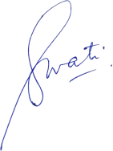Regards,

Swati Yadavendra [Assistant Manager- HR] For Bosleo Techonolgy Private. Ltd.